BIOC 455
Lecture # 15– Glutamate and GABA
Lecturer: Dr. Tak Pan Wong – February 7th, 2007

NOTE: This NTC is meant to be used as a study aid to supplement your own class notes. Hence, not all of the text or diagrams contained in the lecture slides will be reproduced here.

Please send any comments or questions about NTCs to either Wanda or James through e-mail at u3.represent@gmail.com .

Prof . Wong began by giving us further reading material that would be useful for his topics. See chapter 12 of Principles of Neuroscience and most importantly, chapters 15 and 16 of Basic Neurochemistry.

Review:
We can measure current passing through the ion channels by techniques such as voltage-clamp techniques. This current can be inward current or outward current. Inward current is depolarizing current due to the influx of positive ions. Outward current is hyperpolarizing current due to the efflux of positive ions or influx of negative ions.
Most voltage-gated ion channels have the following structure: they have 4 repeats of 6 transmembrane domains with the S4 domain located at the voltage sensor and the linker located between the S5 and S6 domains, which becomes the core region and controls the type of ion influx.

Monosodium Glutamate (MSG):
- First purified by the Japanese for the purpose of enhancing the flavour of food.
- It is industrially produced by the fermentation of sugar.
- Today, it is almost found in every packaged food item.
- 1.5 million tons of MSG is sold each year.
- It is now seen as a negative additive in food, and more people look for organic or at least MSG-free foods.

Glutamate:
- An amino acid (non-essential, as it can be synthesized within the body).
- Can also be found in natural food, so it can be obtained in our diet. It is most prominent in cheese, lesser in tomatoes and even less in red meat.
- Most commonly used excitatory neurotransmitter in the brain (recall, a neurotransmitter (NT) is a chemical substance released by neurons to signal other neurons of the brain when an action potential arrives).
- Mainly located at the presynaptic terminal of a synapse.
- An action potential results in the release of glutamate from the presynaptic terminal and the NT then crosses into the postsynaptic cell.
- Used by 90% of neurons and involved in 80-90% of synapses.
- A precursor of GABA.
- Activates both AMPA receptors (ionotropic transmembrane receptors, activated by glutamate or glutamate’s artificial analog AMPA, that mediate fast synaptic transmission in the CNS) and NMDA receptors (ionotropic receptors whose activation results in the opening of non-specific ion channels that allow the passing of Na⁺, K⁺ and Ca²⁺.

Synaptic Inputs: see slides 5 and 6
- When two sensory neurons that use glutamate as their NT act on one motor neuron, the action potentials received by the motor neuron are additive in two ways. The action potentials and postsynaptic response can be measured by inserting electrodes into all three neurons. The sensory neurons
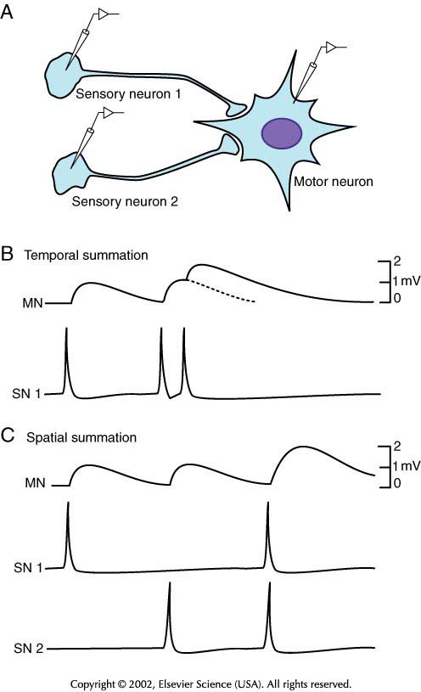
Temporal Summation: when one sensory neuron fires two action potentials without a pause in between, these potentials are additive. In other words, the current increases from the first potential, and before it falls back down, the second action potential causes it to rise again.
Spatial Summation: When two neurons each fire an action potential at the same time, these are additive, so the current rises twice as much as it would if only one action potential were fired.
Summation allows for the initiation of an impulse in the postsynaptic cell even when the presynaptic neurons only weakly synapse to the postsynaptic cell. It allows for depolarization above the threshold.

- Synaptic inputs can be inhibitory (hyperpolarizing – inhibits the formation of action potential) or excitatory (depolarizing – activates the formation of action potential). The former act on the neuronal body and the latter act on the dendrites.

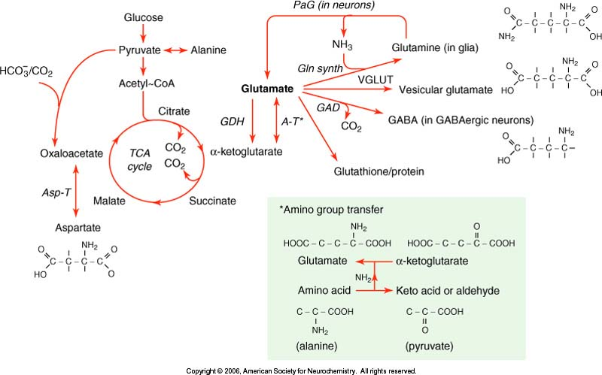Biosynthesis of Glutamate: see slide 9 and 11
- Recall that glucose can be converted into two molecules of pyruvate through the glycolysis pathway. The pyruvate can be used to make acetyl-coA, which enters the TCA cycle to make various intermediates including α-ketoglutarate. α-ketoglutarate and an amino acid (AA) can then undergo an amino group transfer to form glutamate and either a keto acid or an aldehyde depending on which AA was used. The forward reaction is performed by an aminotransferase, and the reverse reaction is done by glutamate dehydrogenase (GDH). GDH allows for the removal of glutamate.

For example, alanine + α-ketoglutarate ↔ pyruvate + glutamate
aspartate + α-ketoglutarate ↔ oxaloacetate + glutamate

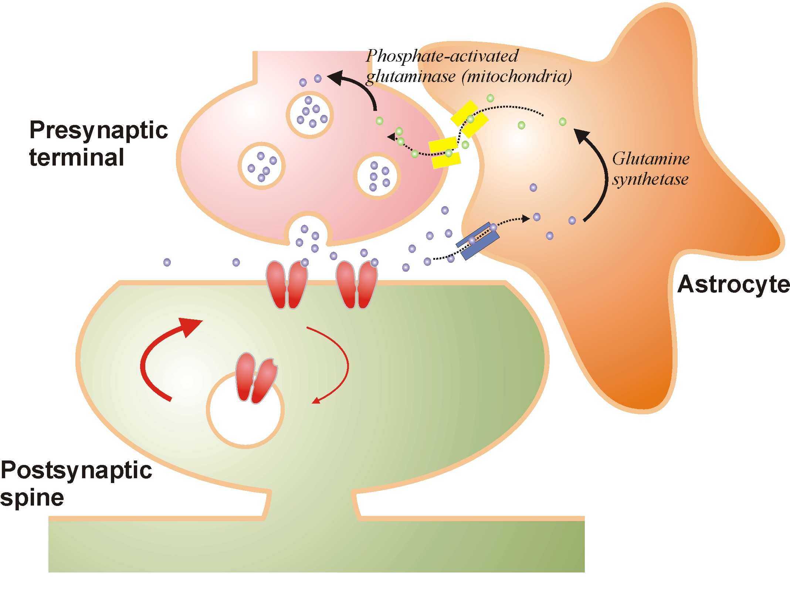
- Glutamate can also be formed via the glutamine cycle or the “recycling of glutamate” by glial cells. An excitatory amino acid transporter (EAAT) in the glial cell transfers the glutamate into the astrocyte, which is a star-shaped glial cell found in the brain. Note that the ratio of glial cells to neurons in the brain is 10:1. Within the astrocyte, an enzyme called glutamine synthetase can convert glutamate into glutamine. Glutamine is an inactive substance in terms of neurotransmission. Glutamine can then re-enter the presynaptic terminal and become glutamate again via phosphate-activated glutaminase, an enzyme in the mitochondria.

Roles of Glutamate:
- Neurotransmitter
- Can provide for important intermediates in cellular metabolism:
- building blocks of peptides and proteins
- intermediates for TCA cycle through transamination by GDH.
- removal of excess nitrogen
- Mediates fast synaptic transmission
  - anesthetics ex. Ketamine
  - learning and memory

Glutamate a Neurotransmitter?
At first, glutamate was not considered a neurotransmitter, and this was thought to be true for quite some time. The reason for this is that molecules must agree with five criteria to be considered NTs. It is now considered a NT as it was finally found to be consistent with all five.
The five criteria are:
  - It is present in the nerve terminal.
  - It’s released from electrically stimulated neurons.
  - There is a mechanism for terminating its action, like the transporter.
  - Its application to target neurons mimics the action of nerve stimulation.
  - Specific receptors exist for it.

Glutamate Receptors:
See slide 14 for a complete list.
Two major subtypes exist. Each subtype has three functional classes, which each has several gene families.
Ionotropic: receptor is an ion channel.
Includes NMDA, AMPA, and Kainate.
Metabotropic: receptor is G-protein coupled (second messenger system).
Includes Class I, Class II, and Class III. Class I results in an increase in inositol triphosphate (IP₃) and an increase in Ca²⁺, while Class II receptors result in a decrease in cAMP.
N.B. There are mGluR4 receptors (Class III) on our tongues, which allow glutamate to result in a good taste. Explains why MSG acts to make food more flavourful.

Ligand- and Voltage-gated channels:
Ligand-gated channels: | Voltage-gated channels:
Activated by agonist (glutamate, AMPA). | Activated by change in membrane potential.
Can allow influx or efflux of many types of ions. | Usually allows one ion through.
No voltage sensor, senses the presence of agonist. | Has a voltage sensor.
Primarily located in postsynaptic membrane. | Widely expressed throughout neuron.

AMPA Receptors (AMPARs):
- Activated by glutamate and AMPA.
- Opening of channel causes depolarization, thereby aiding in the firing of the action potential.
- Most agree that it consists of four subunits (a tetramer), made up of different combinations of GluR1 through GluR4.
- The activated channel is permeable to Na⁺ and K⁺ (Na⁺ enters and K⁺ exits the cell). Those AMPARs that lack GluR2 are also permeable to Ca²⁺.
- Specific antagonist is NBQX. NBQX also inhibits kainate receptors. It is used in experiments to counter glutamate excitotoxicity.
- Generates and excititory postsynaptic current (EPSC).
- The current is fast-rising and fast-depolarizing current. Peak is breif and sharp. It depolarizes very quickly due to the desensitization of the channels. (see slide 20).
- Why is the opening of AMPAR’s depolarizing?
Because of reversal potential. You have more sodium outside and less inside (concentration gradient) so you get an influx of sodium. But, we also have an electrochemical gradient, meaning we want to have an equal amount of positive and negative ions inside and outside the cell, otherwise we will have attractive or repulsive forces affecting the movement of ions. The concentration gradient and the electrochemical gradient combined cause a reversal of potential.

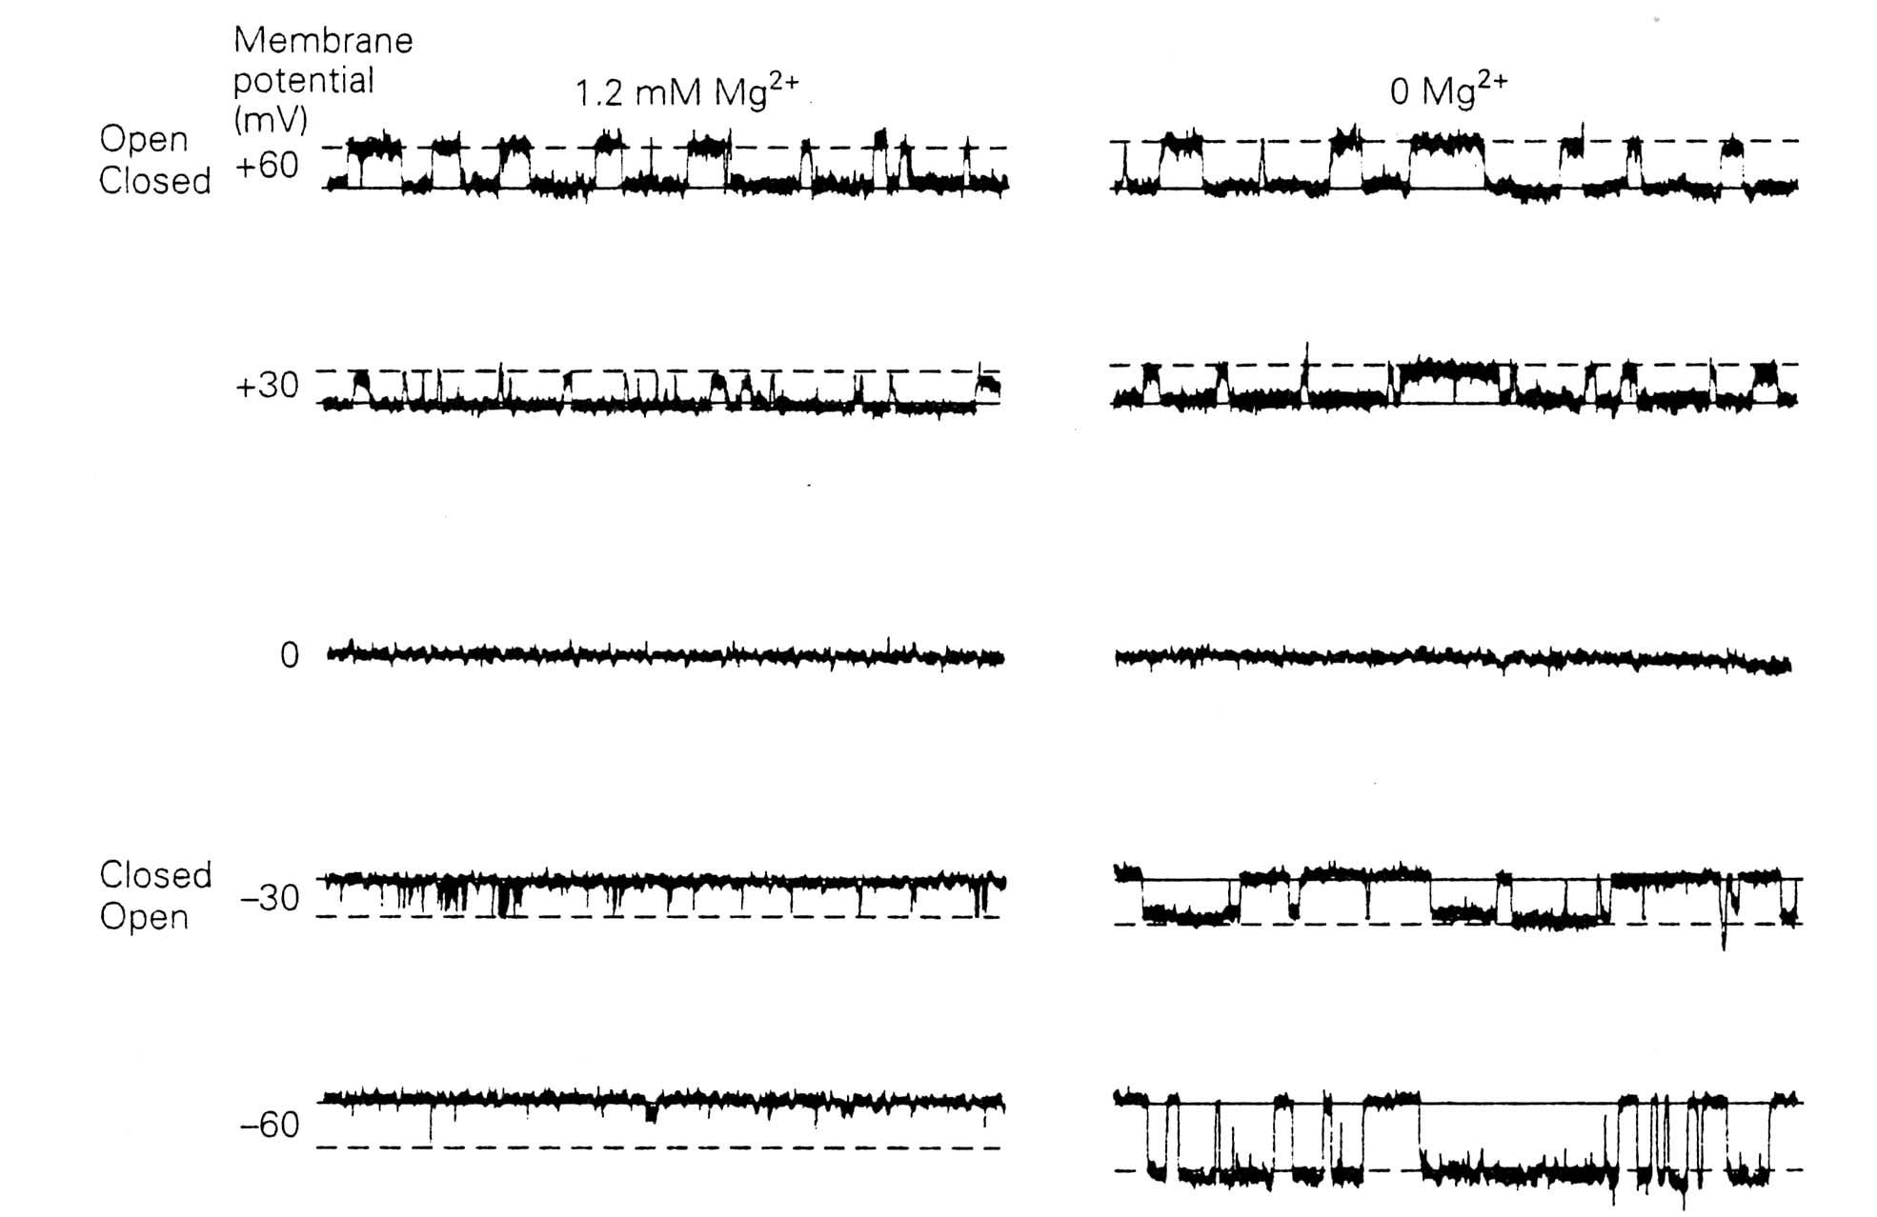
NMDA Receptors (NMDARs):
- Ligand-gated channels like AMPARs, but many differences.
- These channels are inactive at rest. This blockade within the NMDAR is facilitated by Mg²⁺.
In slide 25 and figure at right, we see a recording of one single ion channel. With Mg²⁺ present, there is an appropriate number open channels. We see glutamate induced current only when the channel is sufficiently depolarized. If we take the recording again, but this time without any Mg²⁺ present, we see a huge increase in the number of open channels.
- Since is is normally inactive, it does NOT mediate fast excititory synaptic transmission like the AMPARs did.
- Made of of many (and a varying number of ) subunits, but contains at least one NR1subunit and one NR2 subunit.
- Permeable to Na⁺, K⁺, and Ca²⁺, (Na⁺ and Ca²⁺ come in and K⁺ go out).
- Activated by glutamate, aspartate (in fact, activated by several amino acids), homocysteate, and NMDA.
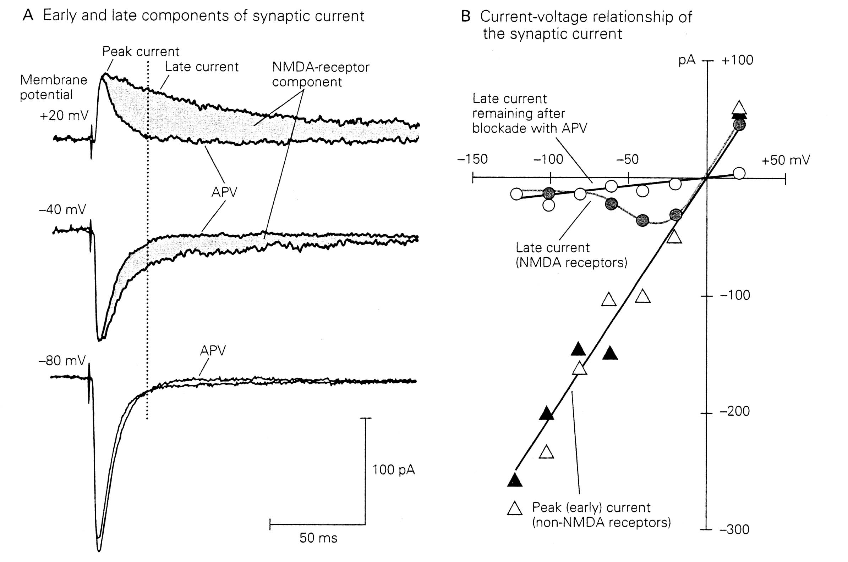
- Binding of the agonist glutamate and the co-agonist glycine activates it.
- Not only activates slowly, but also desensitizes slowly.
- It’s specific antagonist is APV. APV (“AP five”) is a molecule that compeptitively inhibits the active site of the NMDAR. See slide 26: Little NMDARs are active at –80mV with an inward current. After stimulation, the current normally falls slowly (desensitization of the NMDAR is slow), but in the presence of APV the current falls much faster. This shows that APV inhibits NMDARs. In part B we see the current to voltage relationship. We see a late current caused by the NMDARs, but this late current remains when the NMDAR is blocked with APV.
- Can act as a coincidence detector, because depolarization is required for the activation of NMDARs. In other words, it can detect simultaneous activation of the pre- and postsynaptic terminals. Think of a coincidence circuit in physics, the output is activated only when signals are received at both inputs at the same time. If you stimulate the presynaptic terminal, you cause the release of glutamate and will result in a slight depolarization. This slight depolarization of around –55mV, will not be sufficient to trigger an action potential so the NMDARs will not open. However, if you stimulate the presynaptic terminal with higher frequency, you cause a release of glutamate and can cause an action potential. So, the opening of NMDARs will tell the neurons that there is a coincidence activation of presynaptic terminals and also a postsynaptic activation, which is the generation of action potentials. These signals are what make NMDARs so important for learning and memory.

Synaptic Plasticity:
- Calcium flux through NMDARs is thought to play a critical role in synaptic plasticity.
- Is the ability of the synapse between two neurons to change in strength. This plasticity can occur with a change in how much NT is released or with how effectively the cell responds to the NT or the number of ion channels present, etc.
- An important phenomenon when we talk about learning and memory.
- Types of synaptic plasticity: In Slide 28 we look at the rat brain with the hypocampus coloured in green. The hypocampus is the most important brain region for memory formation. If we cause a high frequency stimulation of a pathway in this region that is mediated by glutamate, we can increase the strength of the synaptic transmission persistantly for weeks. This phenomenon is called long-term potentiation (LTP). LTP is an increase in the chemical strength of a synapse that lasts from minutes to several days. This can be achieved in vitro by applying a series of short, high-frequency electric stimuli to a synapse thereby strengthening, or potentiating, the synapse. In vivo, LTP can occur and can last from minutes to years. LTP is thought to be the explanation of how we form memories, because the cell remembers the extent to which it was stimulated, and maintains this strength. Long-term depression (LTD) is the weakening of a synapse that can last from hours to days. It can be caused by persistent strong synaptic stimulation or persistent weak stimulation.

Drugs and NMDARs:
Near the Mg²⁺ blocking sites in the NMDAR, there are also binding sites for drugs that act as antagonists on the receptor. For example, PCP (angel dust) and other recreational drugs inactivate the NMDARs, causing hallucination. Ketamine is another antagonist, which can be used as an anesthetic. In the picture we can see that there are various binding sites on the receptor for agonists, antagonists and co-agonists (glycine).
NMDARs are also modulated by phosphorylation, which regulates their function and may play a role in many forms of synaptic plasticity such as long-term potentiation.

Learning and Memory:
One of the most important functions of NMDARs is their role in learning and memory. We were shown a movie of the Morris water maze test, in which a rat was placed in a large round container of water in an isolated room. In the water was a hidden platform that was just below the water’s surface so it was impossible to see. See slide 33: Trail 1 shows that the rat circles round and round for quite some time until it finds the platform. Trail 8 shows that if the rat is placed in the water seven times and each time we pick it up and show it where the platform is, eventually the rat will swim directly to the platform when placed in the water.
On slide 34 we have an experiment that shows that if NMDARs are blocked, memory is abolished. The control shows that an experienced rat will swim toward where the platform should be. The reason why the trail does not just stop is that the platform was removed. On the right we have the same rat, but its NMDARs have been blocked resulting in a loss of memory. This rat swims in a random pattern, because it no longer knows where the platform should be.

Excitotoxicity:
- The over-activation of glutamate receptors, causing neuronal damage and cell death.
- One experiment involved the injection of MSG into retina cells, which caused cell death.
- For example, the stroke condition, which involves the blockade or burst of blood vessels, called ischemia, resulting in no oxygen and no sugar in the blood. This leads to a decrease in energy supply to the cell. As a result, the cell depolarizes causing NT release and the opening of Ca²⁺ channels. The glutamate released results in the activation of the NMDARs and AMPARs, leading to a further increase in Ca²⁺. Increased Ca²⁺ causes neuronal injury. This neuronal injury and the receptor activation both act as positive feedback loops by causing even more cell depolarization.
- In slide 37 we see how the Ca²⁺ causes neuronal injury. Ca²⁺ activates nitric oxide synthase, releasing NO⁻, it lowers the energy production by mitochondria, activates proteases, disrupts the cytoskeleton, damages DNA, and inactivates synthetic enzymes. All the these cause cell death.

NMDAR and Schizophrenia:
It is thought that the decreased function of NMDARs is the cause of schizophrenia. Similar to the effect of PCP on the NMDARs, this inactivation leads to psychotic symptoms. So, it is reasonable to think that schizophrenia could be treated by targeting the NMDARs.

Next class: GABA and the discussion of the article.

